Lab – 5 – AWS CloudFormation
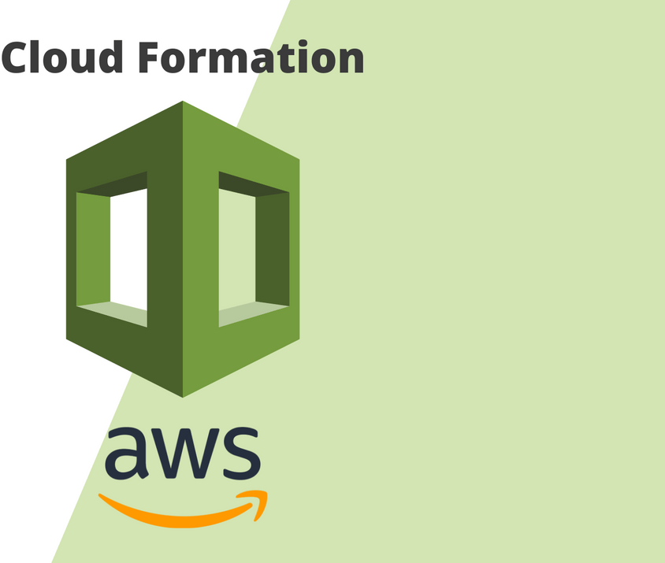

What is CloudFormation?
AWS CloudFormation is a service that gives developers and businesses an easy way to create a collection of related AWS and third-party resources, and provision and manages them in an orderly and predictable fashion. AWS CloudFormation is a service that helps you model and set up your Amazon Web Services resources so that you can spend less time managing those resources and more time focusing on your applications that run in AWS. You create a template that describes all the AWS resources that you want (like Amazon EC2 instances or Amazon RDS DB instances), and AWS CloudFormation takes care of provisioning and configuring those resources for you without the need for individually creating and configuring AWS resources and figure out what's dependent on what.
AWS CloudFormation simplifies provisioning and management on AWS. You can create templates for the service or application architectures you want and have AWS CloudFormation use those templates for quick and reliable provisioning of the services or applications (called “stacks”).
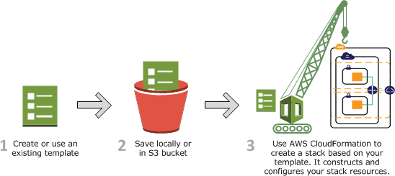

Working with CloudFormation templates

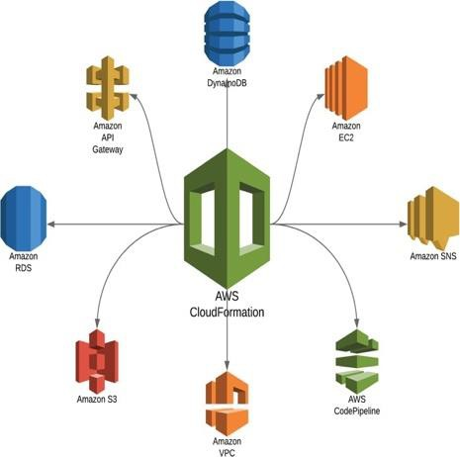

To provision and configure your stack resources, you must understand AWS CloudFormation templates, which are formatted text files in JSON or YAML. These templates describe the resources that you want to provide in your AWS CloudFormation stacks. You can use AWS CloudFormation Designer or any text editor to create and save templates.
If you're unfamiliar with JSON or YAML, you can use AWS CloudFormation Designer to help you get started with AWS CloudFormation templates. AWS CloudFormation Designer is a tool for visually creating and modifying templates.
For more information, see What is AWS CloudFormation Designer?.

In this lab, we will learn how to navigate and work through AWS CloudFormation.
A CloudFormation template is attached along with the lab file, this will create a CloudFormation stack consisting of EC2 instances, a Security Group for logging in to that instance, and an S3 bucket.

We will use the AWS Management Console for performing most of our tasks.

PART 1: Inspect the CloudFormation template and answer the questions. (50 Marks)

Let us start by inspecting the CloudFormation template.
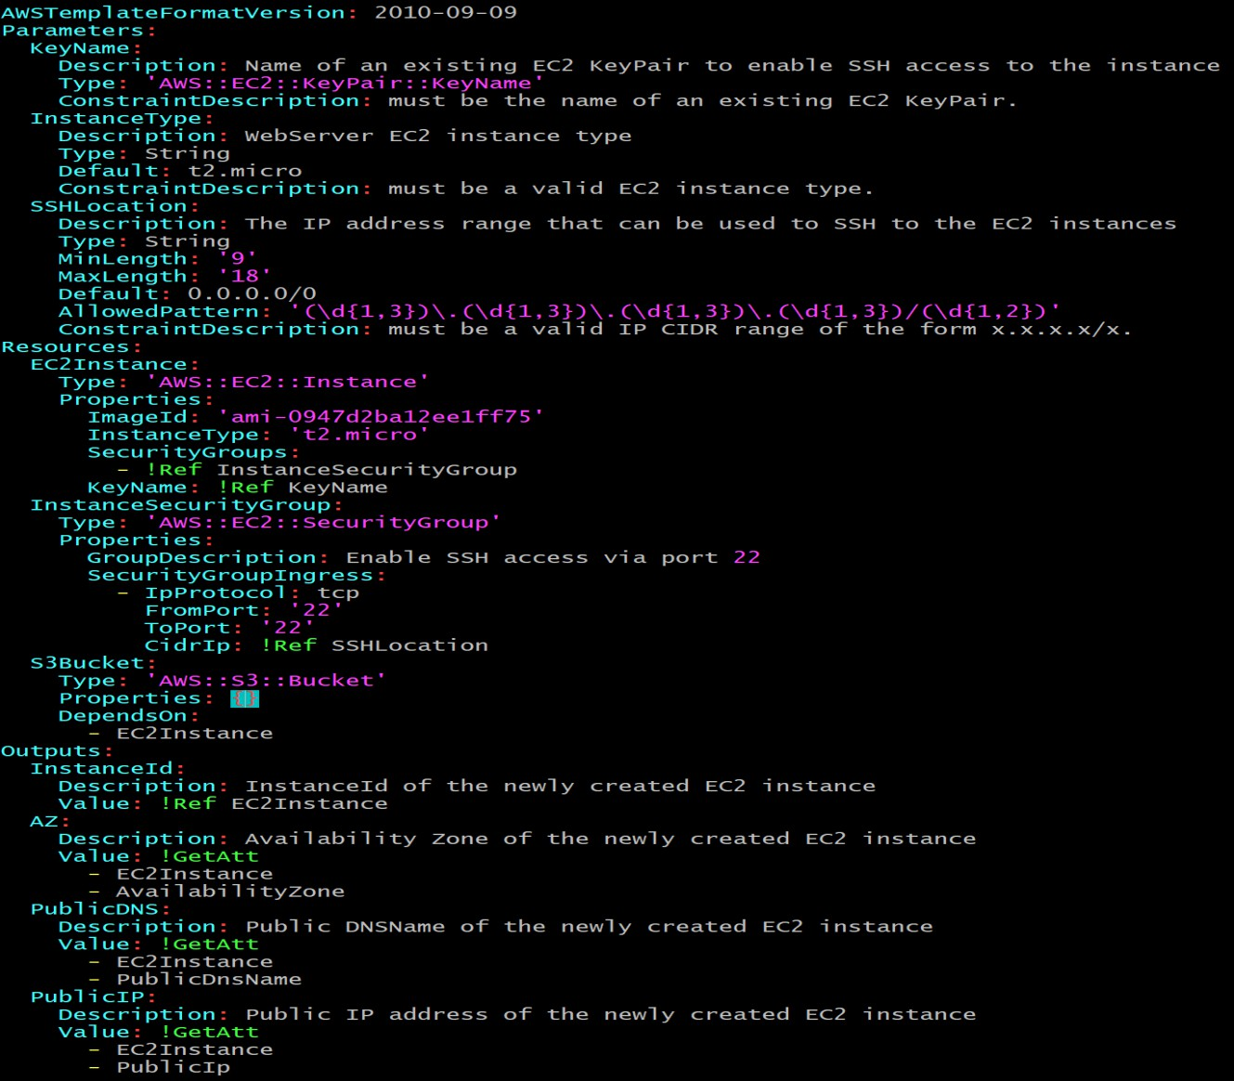

For a generic CloudFormation template, explain the following sections in detail:

- Parameters
- Resources
- Outputs

Now we will focus on every section of the given template.

PARAMETERS:

In the below snippet, explain every single line in detail starting from Parameters and ending with Constraint Description in SSHLocation.
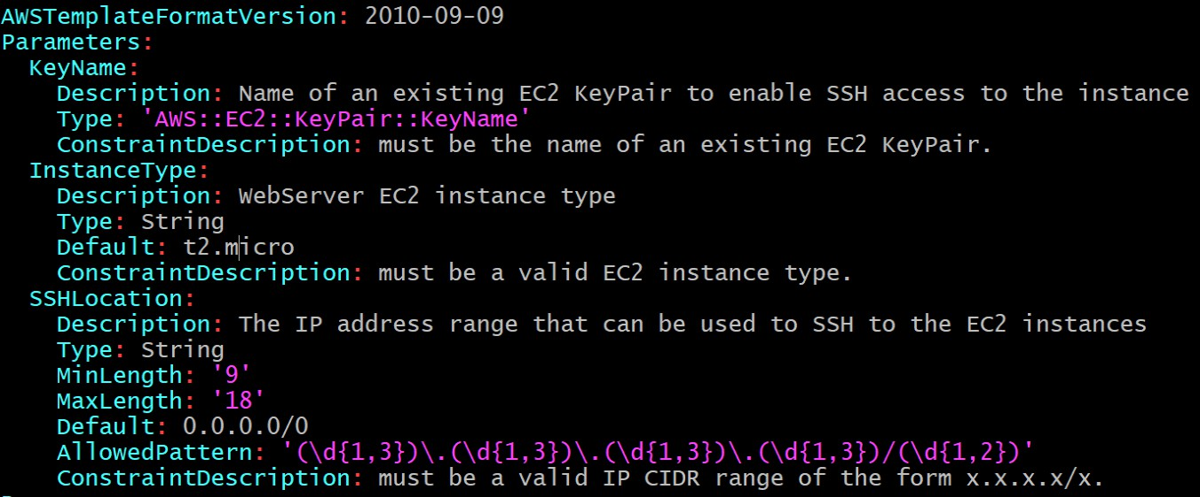

RESOURCES:
In the below snippet, explain every single line in detail starting from Resources and ending with DependsOn attribute
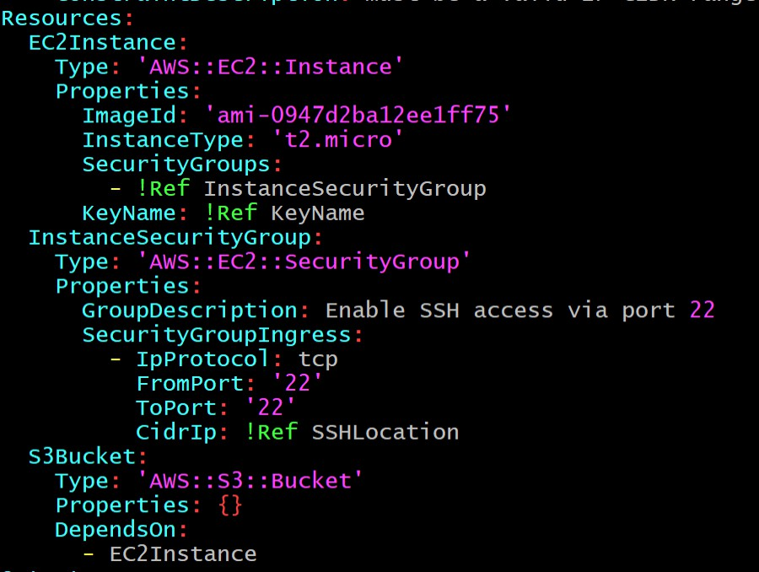

OUTPUTS:
In the above snippet, explain every single line in detail starting from Outputs and ending with Value

Explain what is !Ref, !GetAtt, what is the significance of (!)
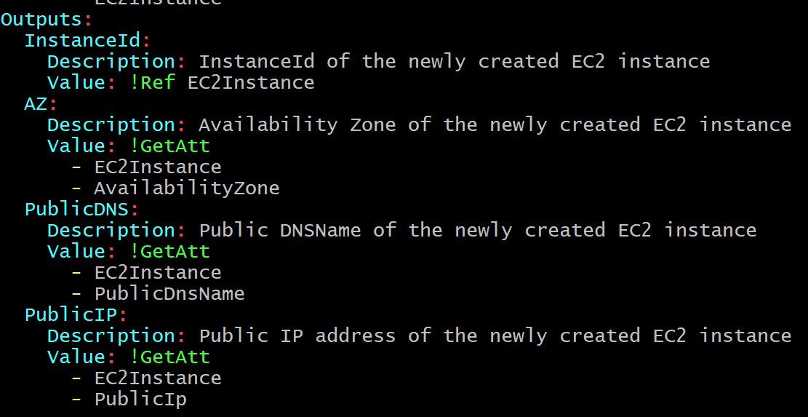

PART 2: (Add Screenshots for every Step performed) (50 Marks)
Step 1: Create an EC2 key-pair (Name of the key-pair should be CF-<yourname>)
Note: Download the key in ‘pem’ file format if you are using Linux/Mac and for Windows download in ‘ppk’ file format.
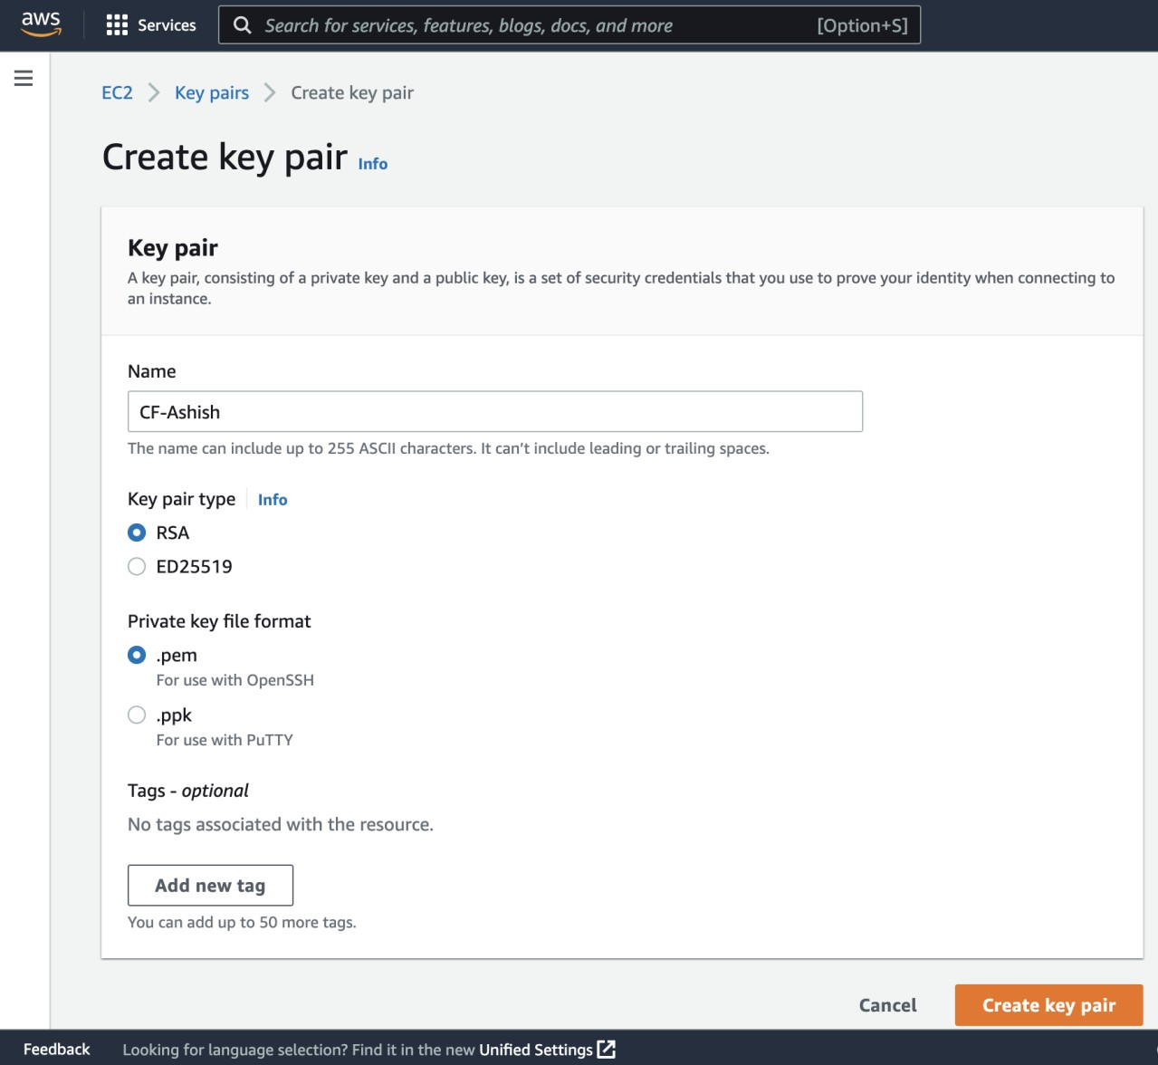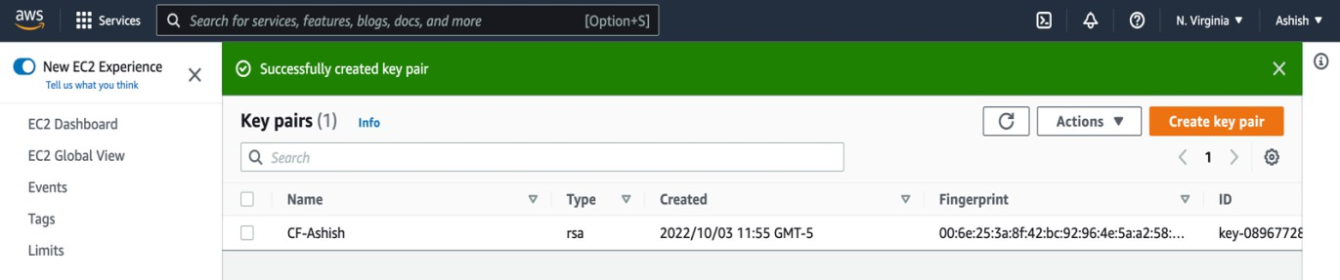

Step 2:
Now navigate to CloudFormation and ‘Create stack’ using the YAML file attached and then before clicking on ‘Next’, click on the ‘View in Designer’ tab to view the topology in AWS CloudFormation Designer.
Note: AWS CloudFormation Designer enables you to diagram your template resources using a drag-and-drop interface, and then edit their details using the integrated JSON and YAML editor.
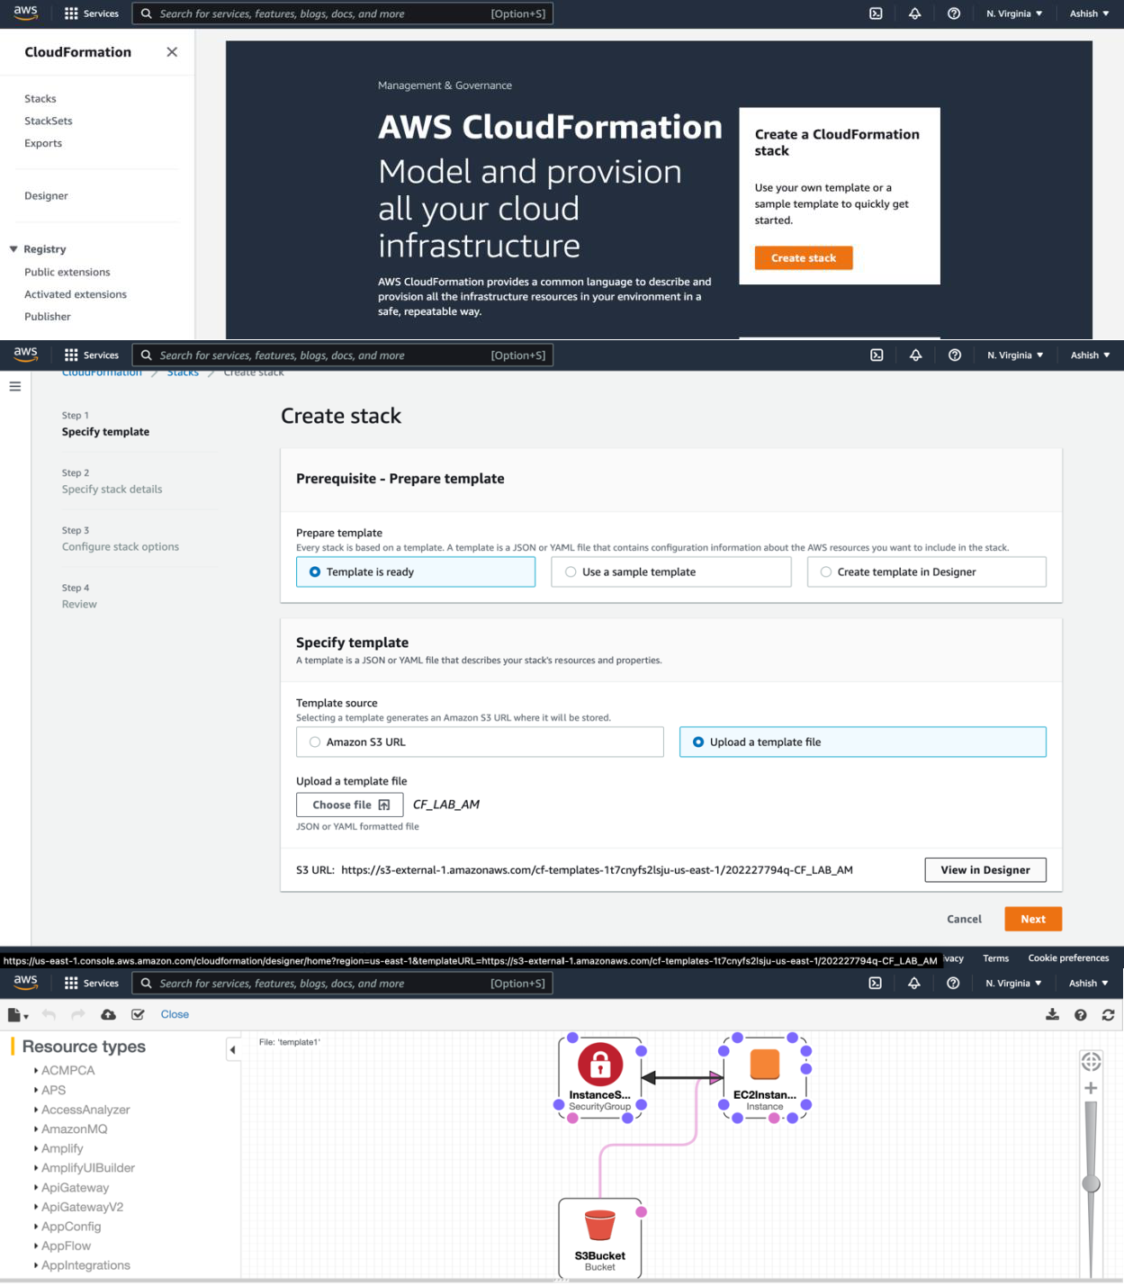

Give the Stack name as ‘CF-lab-<yourname>’ and in ‘KeyName’, select the EC2-KeyPair created in Step1, after this, select all defaults and click on ‘Create stack’.
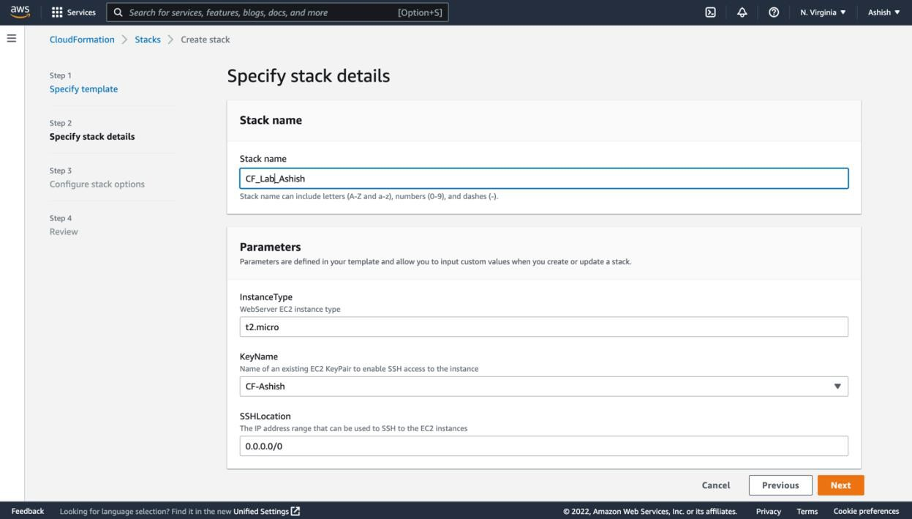

It might take a few minutes for resources to be created, but once it is done your output should look like as shown
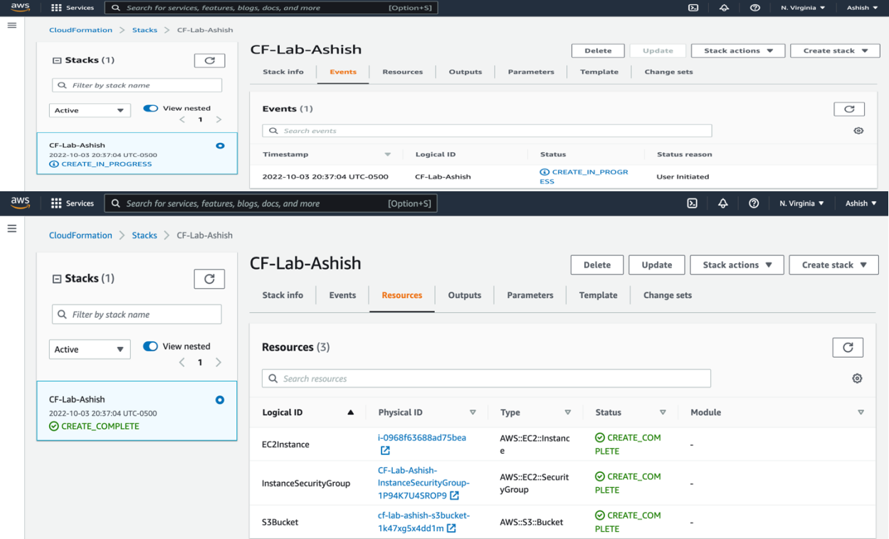

Step3: Connect to the EC2 instance via SSH using the EC2 key pair downloaded previously.

(Login as ‘ec2-user’ as shown in the screenshot below)
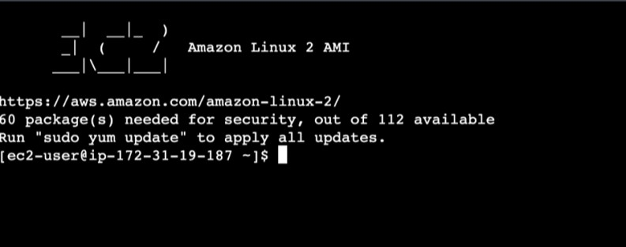

Step4: Check the Security Group created.

The theory question follows:
Q) Explain what Inbound and Outbound rules are with an example of each.
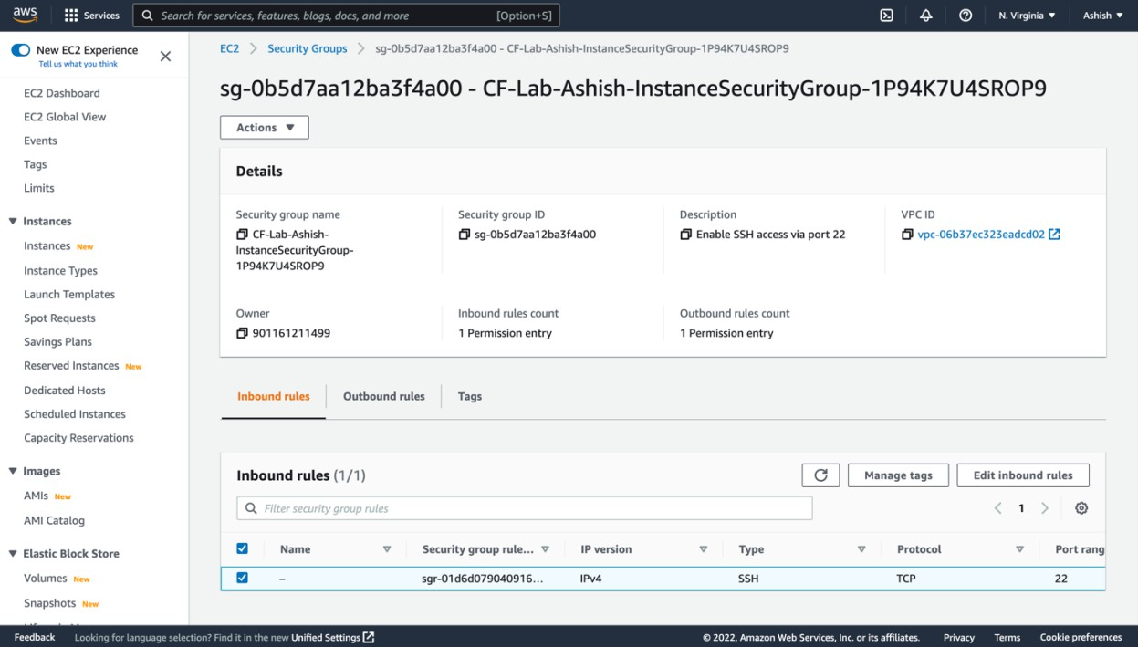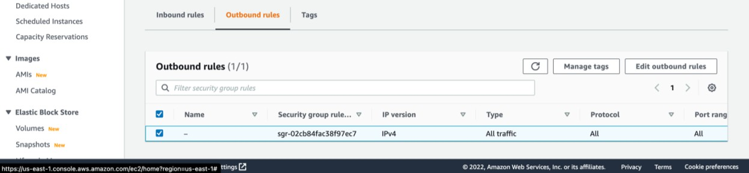

Step5: Check the S3 bucket created.
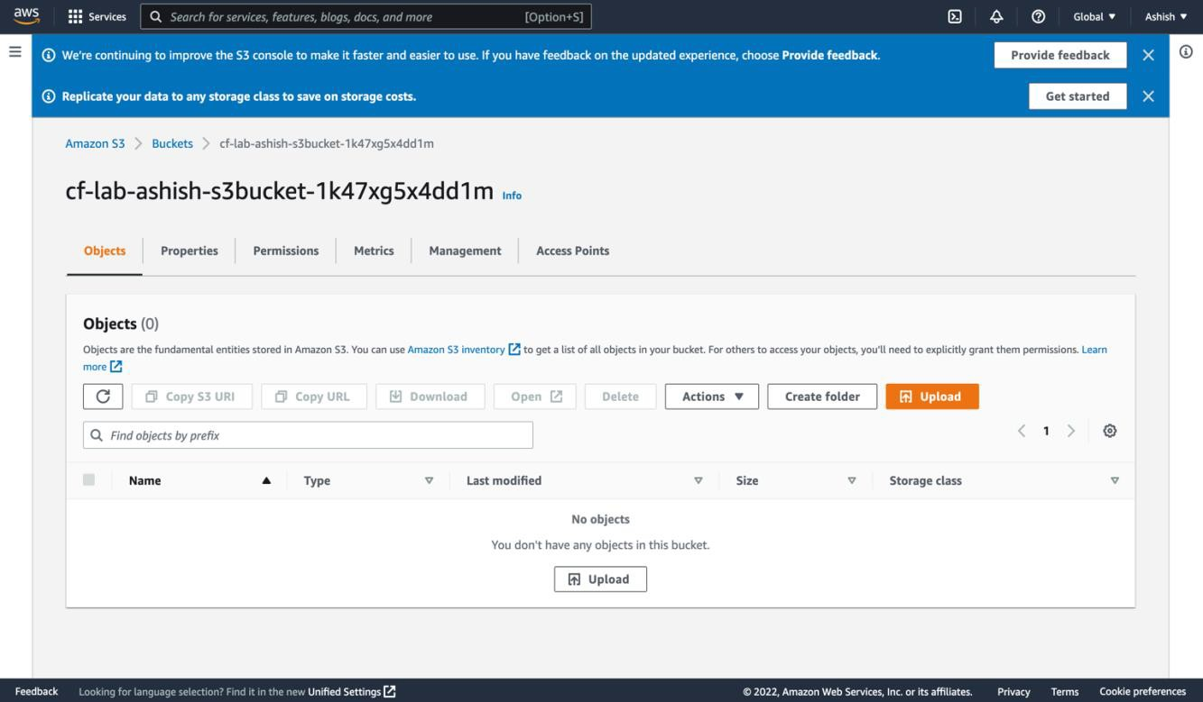

The theory question follows:
Q) Explain what is S3 bucket and explain the properties, permissions, management, and access points in the above snippet.
Step6: Look for the following output:
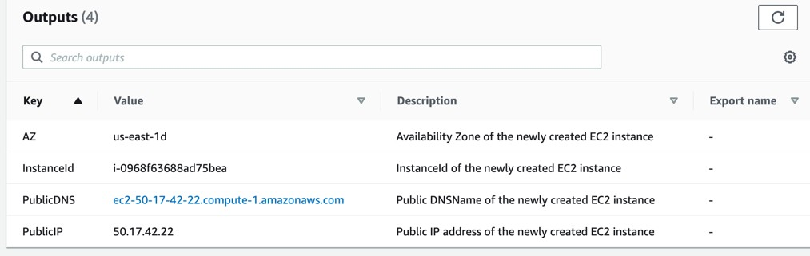
DELETE THE TEMPLATE AFTER YOUR LAB
End of Lab

